A000- Paleo-Mammoth-Mammuthus primigenius-Molar-Baltic Sea

**Mammoth molar from Baltic Sea, ca. 12,000 years old.**

**This superbly preserved upper molar of *Mammuthus primigenius* was retrieved (during oil exploration) from sediments of the Baltic Sea that was a land bridge 12,000 years ago but was inundated by rising sea levels as the climate warmed.**

**Mammoths arose in Africa, and evolved from *Mammuthus meridionalis* (Late Pliocene (3.6-2.5 million years BP) to *Mammuthus trogontherii*, to the woolly mammoth *Mammuthus primigenius* (Late Pleistocene), which first appeared in Siberia and then migrated west to Europe about 200,000 years ago. (Maglio, 1973; Lister, 1996; Lister and Sher, 2001).**

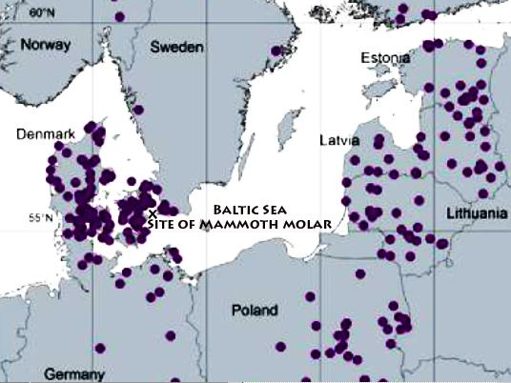 **Map of mammoth sites in the circum-Baltic area with the approximate location of the mammoth molar site.**

**The importance of this molar is that it represents the last evolutionary stage of the wooly mammoth that persisted from 30,000 years ago to the Pleistocene-Holocene boundary about 12,000 years ago. This was a period of intense cold. Food was tough, coarse tundra grasses, which can quickly wear down most teeth. However, an efficient grinding surface was maintained because as the dense enamel ridges were ground down, the dentine being softer than enamel was removed also and the alternating enamel ridges were preserved for efficient grinding of coarse food.  Another adaptation to this cold environment was to reduce the surface area of the mammoth's body, ears and trunk because they dissipated core body warmth (which had originally been useful in dissipating heat in Africa). In addition, the wooly mammoth developed a thicker pelt and a layer of fat. Therefore, as wooly mammoths became smaller and fatter, their bodies became warmer. The adult woolly mammoth, from which this molar came, stood around 10 - 12 feet high at the shoulder and weighed 6 - 8 tons, about the same size as a present day Indian elephant but with an additional layer of fat and fur.**

**References**

**Lister, A.M., 1996. Evolution and taxonomy of Eurasian mammoths. In: Shoshani, J., Tassy, P. (Eds.), *The Proboscidea: Evolution and Palaeoecology of Elephants and their Relatives*. Oxford University Press, Oxford, pp. 205–211.**

**Lister, A.M., Sher, A.V., 2001. The origin and evolution of the woolly mammoth. *Science* 294, 1094 1097.**

**Maglio, V.J., 1973. Origin and evolution of the Elephantidae.*Transactions of the American Philosophical Society* 63 (3), 149.**